**How to Backup our files Using Jenkins**

1. Make a directory for storing your jenins backup by using the following commands:
2. sudo mkdir /data
3. Sudo mkdir /data/Jenkins
4. Sudo mkdir /data/Jenkins/backups

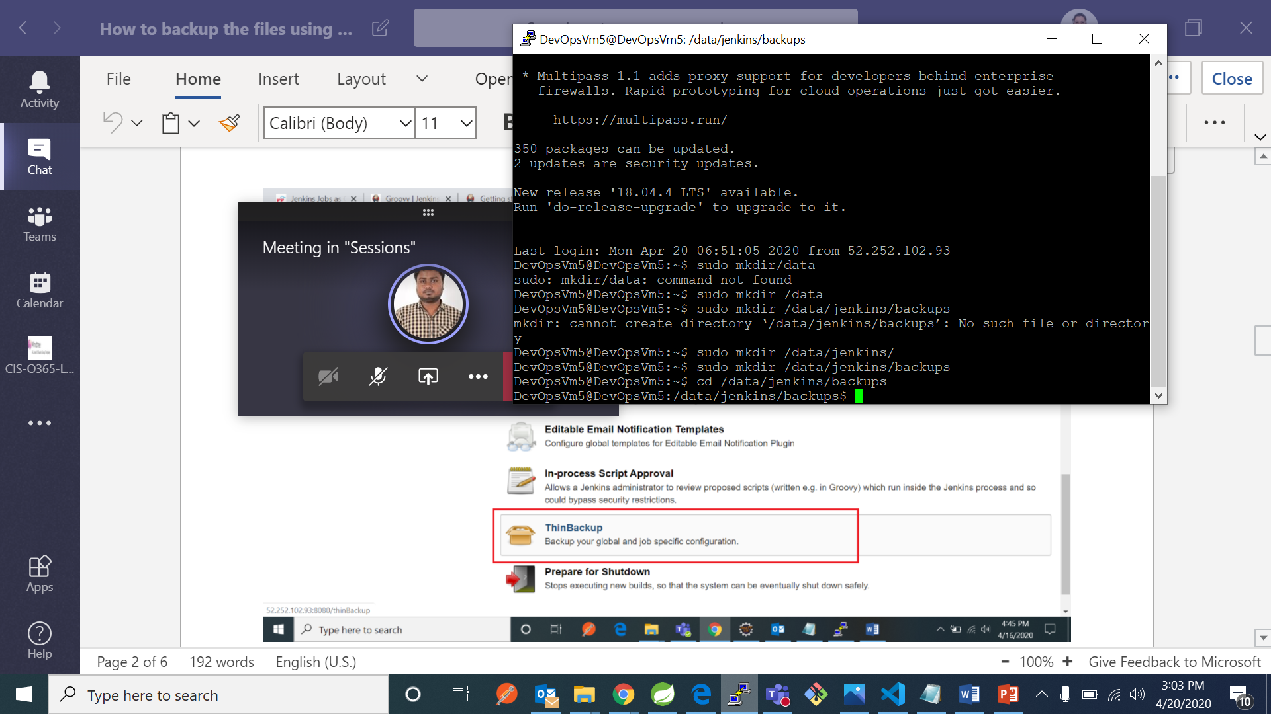

1. Now open Jenkins go to manage Jenkins -> manage plugins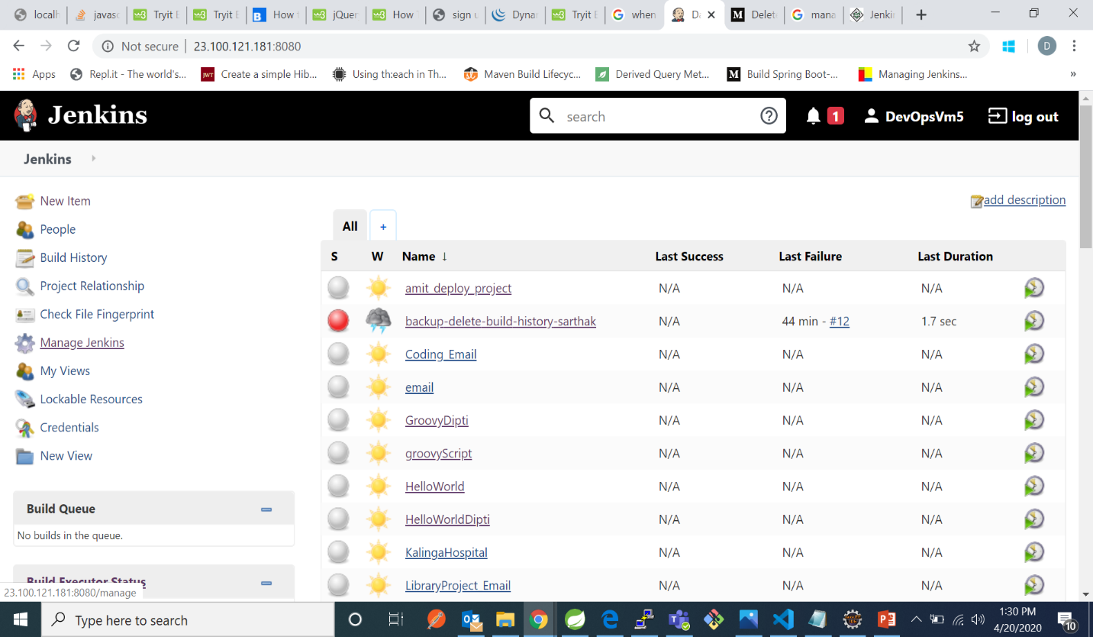

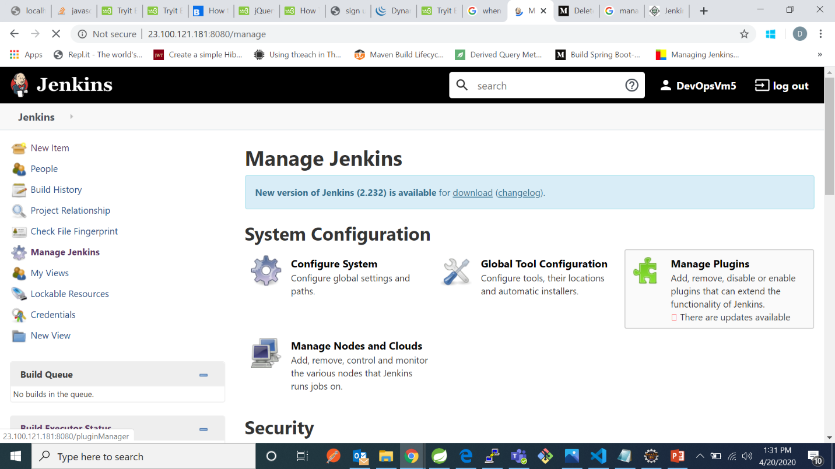

1. Now go to available search for thinbackup and then click on install without restart

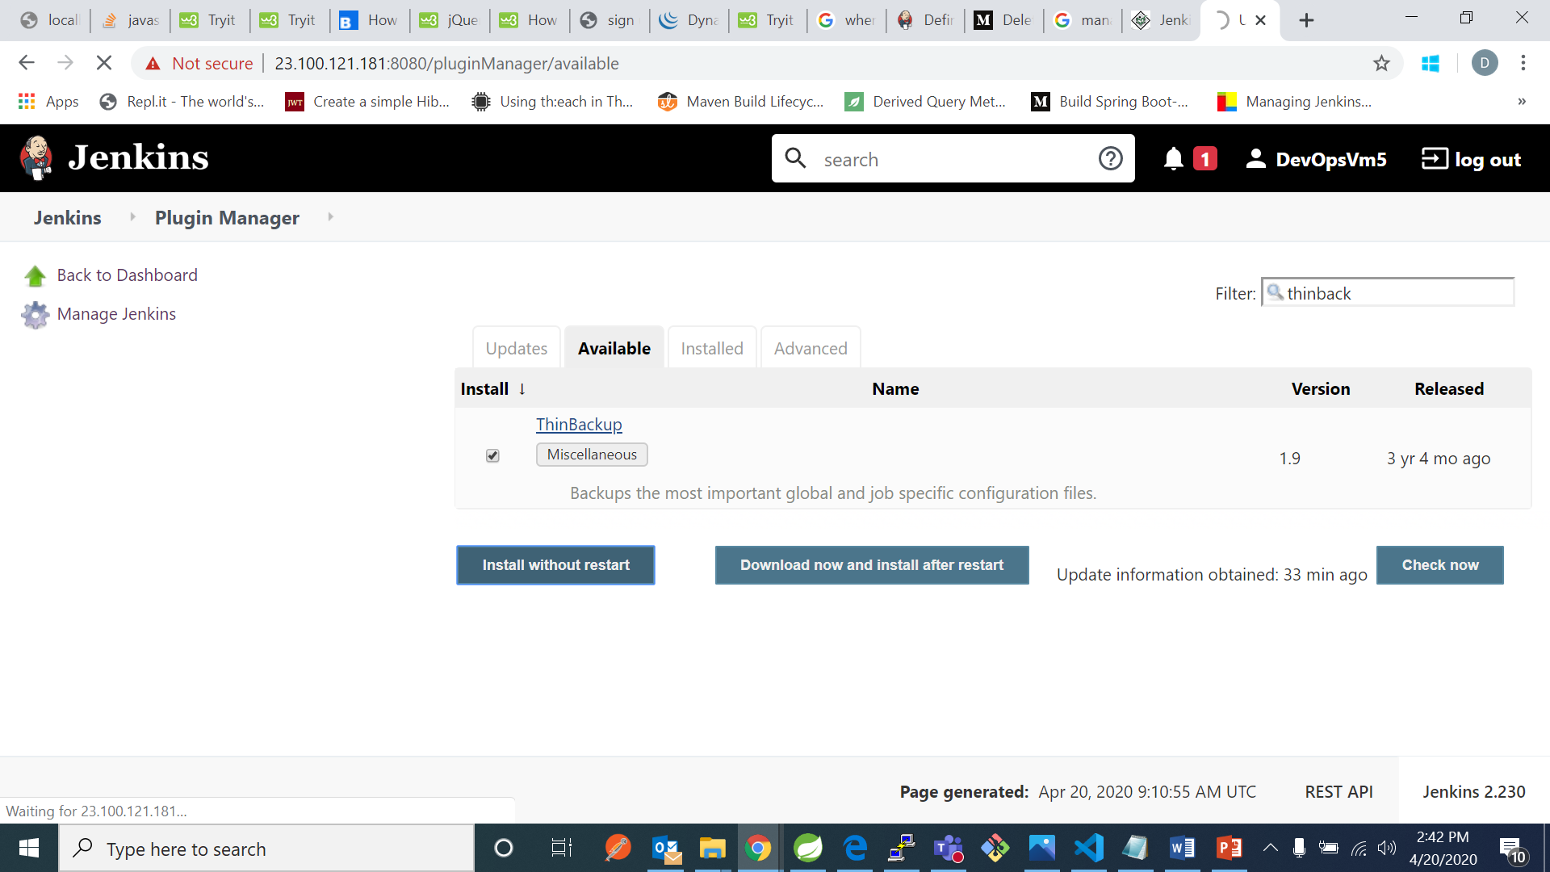

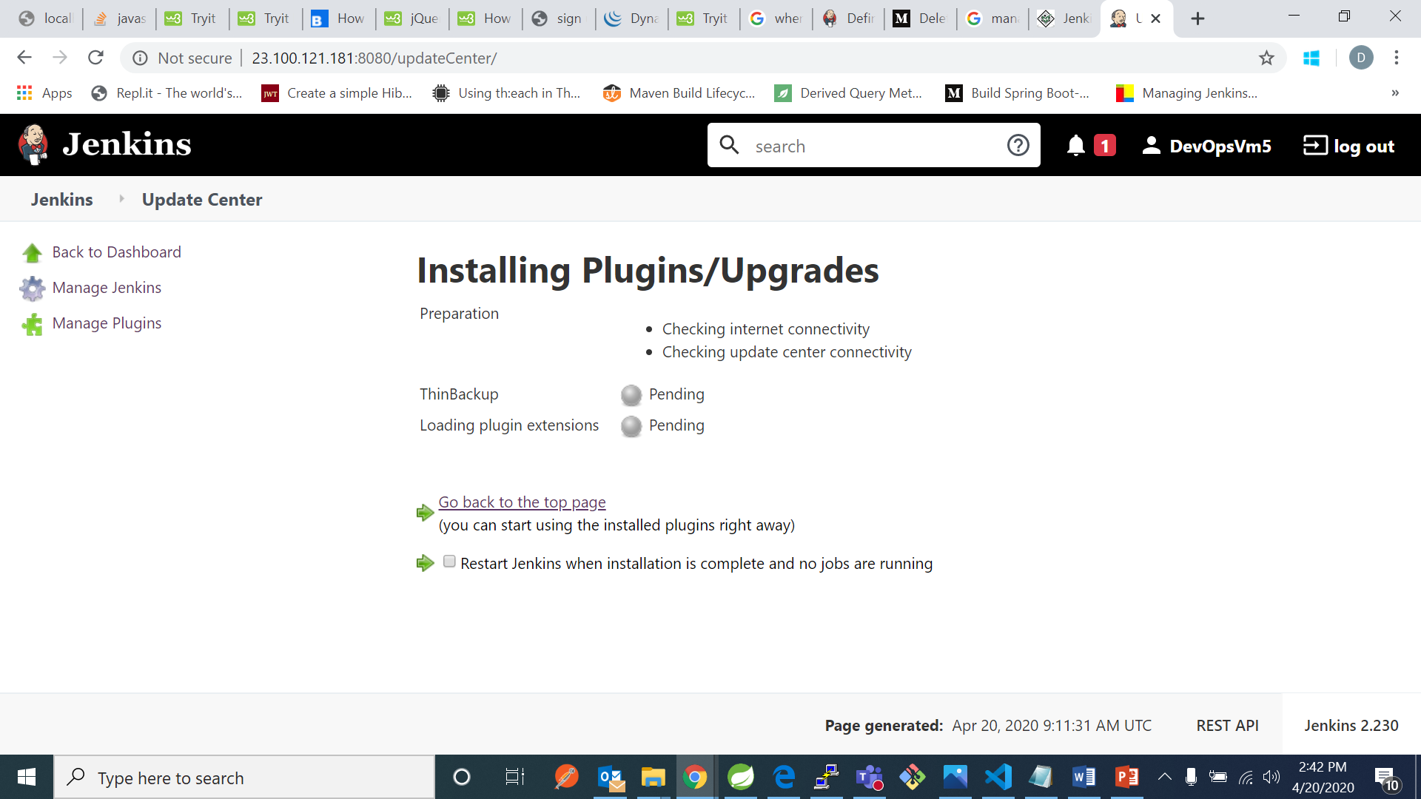

1. Now you can check in manage Jenkins in “uncategorized” category -thinbackup

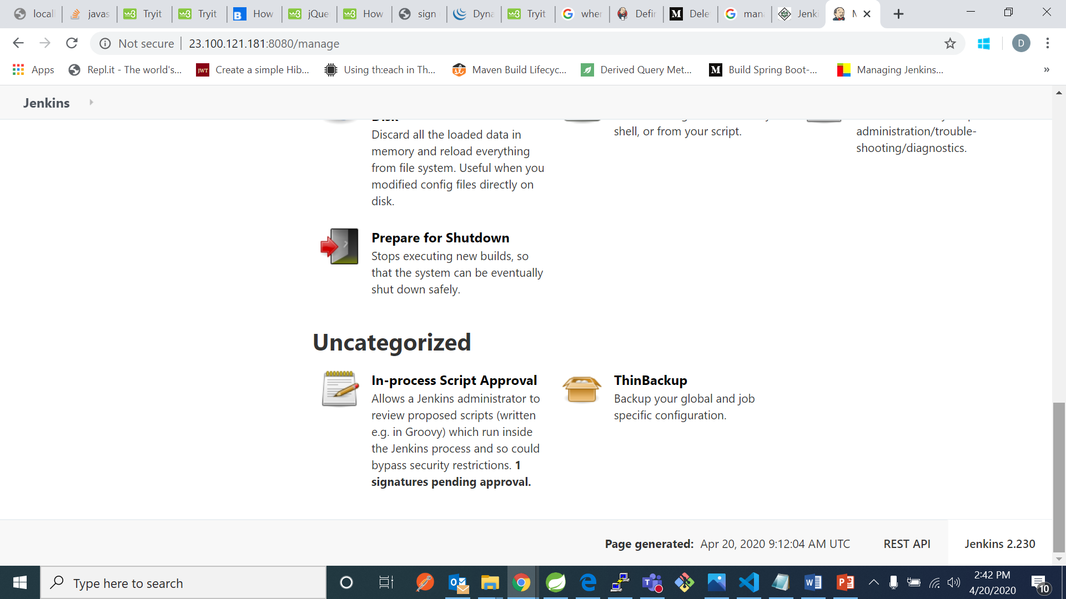

1. Click on thinbackup nad then on settings

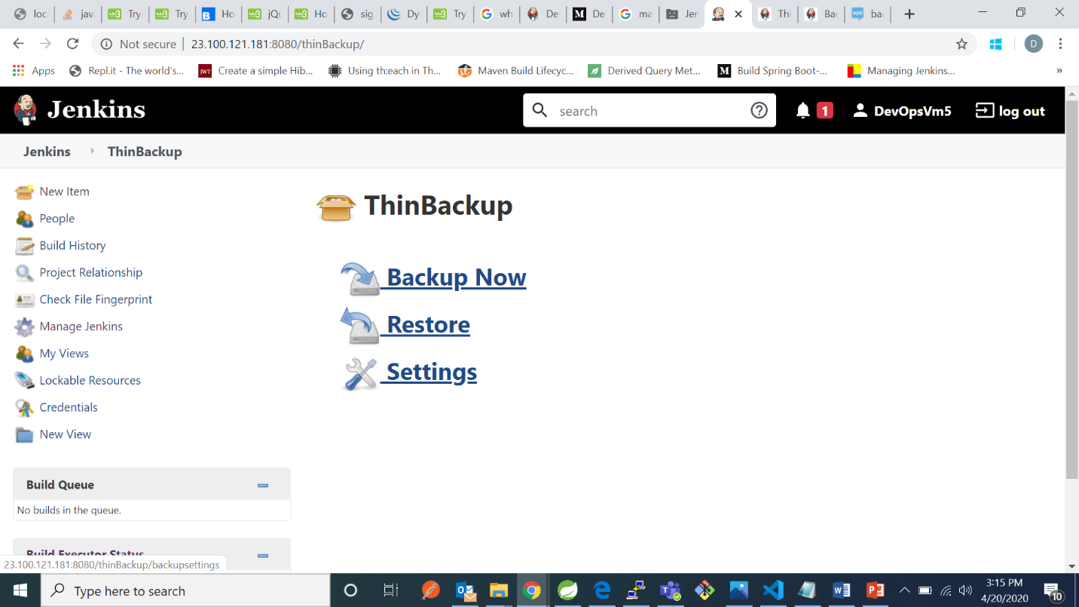

1. Now in backup directory write the earlier created directory of backups in VM. In backup schedule for full backups and for differential backups mention :

MINUTES Minutes in one hour (0-59)

HOURS Hours in one day (0-23)

DAYMONTH Day in a month (1-31)

MONTH Month in a year (1-12)

DAYWEEK Day of the week (0-7) where 0 and 7 are Sunday.

*-stands for every time or day or month

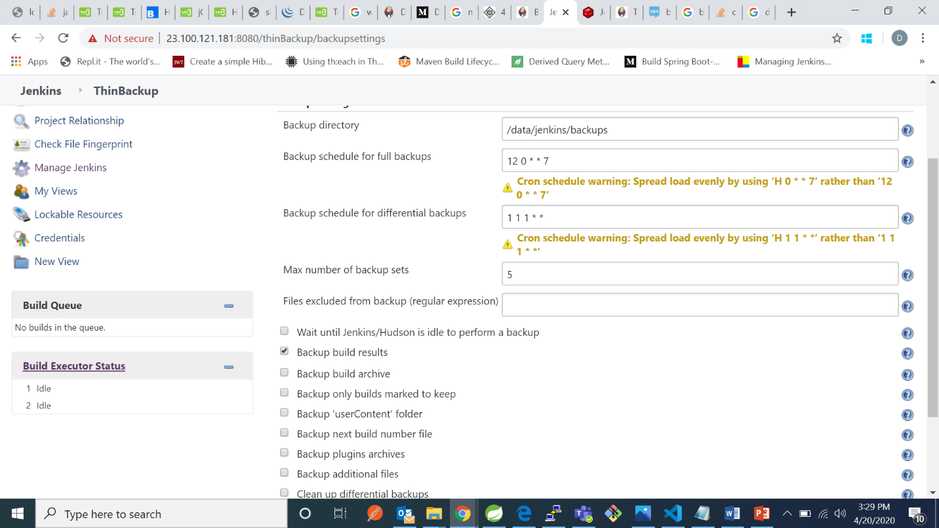

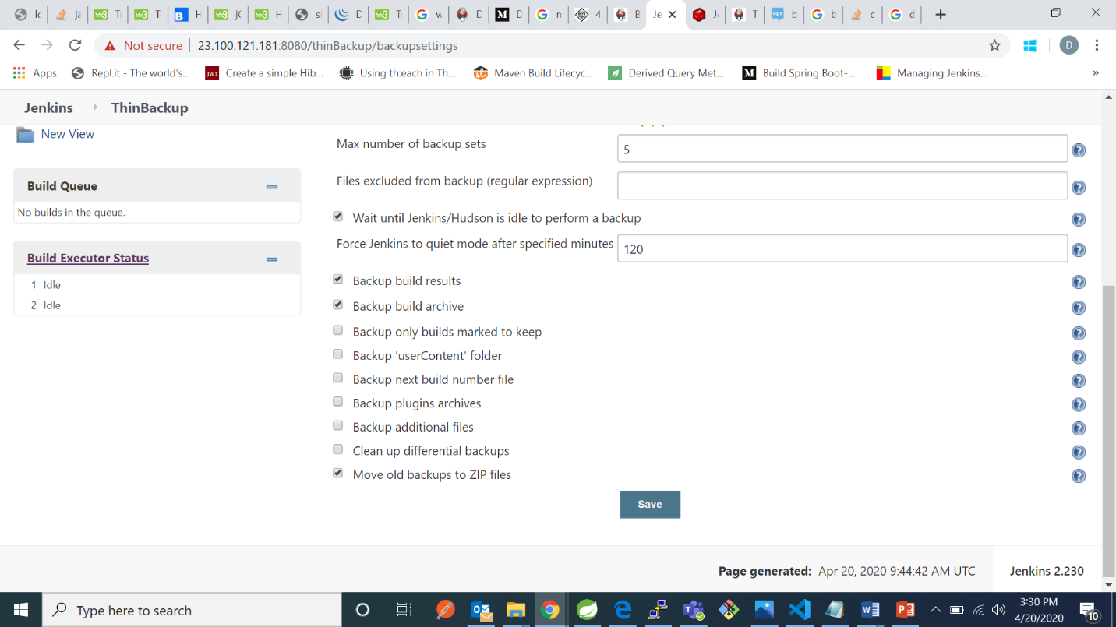

1. Now we can check by moving to backups directory that all the backups has been done

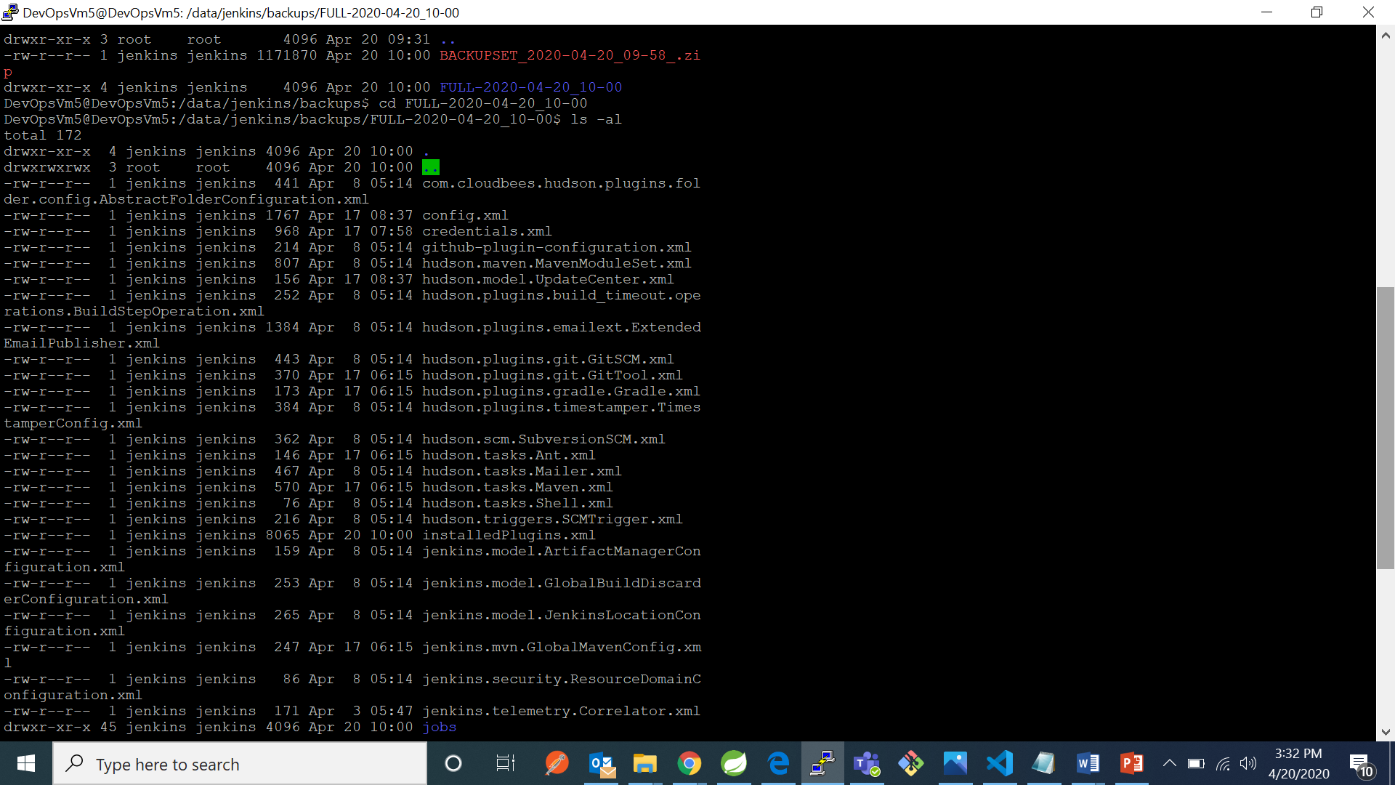

1. If we want to check for projects backup type : “ cd jobs” and then “ls” command



